VASBO
Spring Apparel Program
VASBO

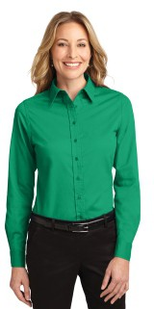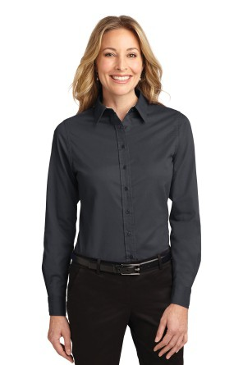

#L608 Port Authority, Ladies
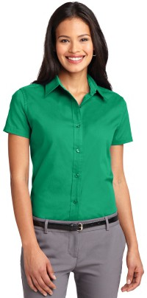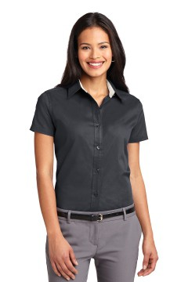Court Green or Navy

Small-XL $ 22.79
2X 24.25
3X 27.25

#L508 Port Authority, Ladies Easy Care Shirt, Short Sleeve Court Green or Navy/Stone
XSmall-XL $ 21.30
2X 22.88
3X 24.25

#S608 Port Authority, Men’s Easy Care Shirt, Long Sleeve Court Green or Navy/Stone
XSmall-XL $ 22.79
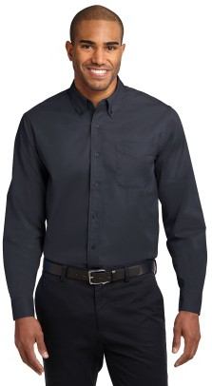
2X 24.25
3X 27.25
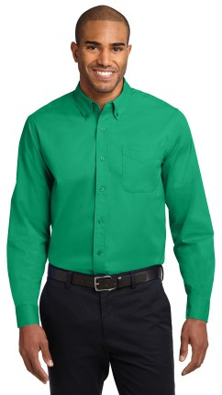

#L608Port Authority, Men’s Easy Care Shirt, Short Sleeve Court Green or Navy/Stone 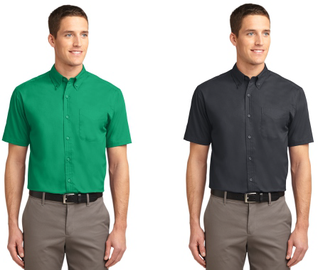
XSmall-XL $ 21.30
2X 22.88
3X 24.25

All items embroidered, folded and bagged Prices include VA Sales Tax.

Name: Contact:
Item #1: Style# Color: Size: Price:
Item #2 Style# Color: Size: Price:
Item #3 Style# Color: Size: Price:
Total:

#L608

HOW TO MEASURE
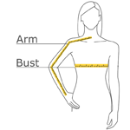

BUST
With arms down at sides, measure around the upper body, under arms and around the fullest part of the bust.

ARM
Place hand on hip. Start at the center of the back of the neck and measure across the shoulder, to the elbow, and then down to the wrist.

SIZE CHART
 | XS | S | M | L | XL | XXL | 3XL | 4XL | 5XL | 6XL
Size | 2 | 4/6 | 8/10 | 12/14 | 16/18 | 20/22 | 24/26 | 28/30 | 32/34 | 36/38
Bust | 32-34 | 35-36 | 37-38 | 39-41 | 42-44 | 45-47 | 48-51 | 52-55 | 56-59 | 60-63
Arm | 30 - 30 3/4 | 30 3/4 - 31 1/2 | 31 1/2 - 32 | 32 - 32 1/2 | 32 1/2 - 33 | 33 - 33 3/8 | 33 3/8 - 33 3/4 | 33 3/4 - 34 1/2 | 34 1/4 - 34 3/4 | 34 1/2 - 35

#L508

HOW TO MEASURE
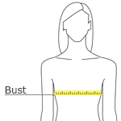

BUST
With arms down at sides, measure around the upper body, under arms and around the fullest part of the bust.

SIZE CHART
 | XS | S | M | L | XL | XXL | 3XL | 4XL | 5XL | 6XL
Size | 2 | 4/6 | 8/10 | 12/14 | 16/18 | 20/22 | 24/26 | 28/30 | 32/34 | 36/38
Bust | 32-34 | 35-36 | 37-38 | 39-41 | 42-44 | 45-47 | 48-51 | 52-55 | 56-59 | 60-63

#S608

HOW TO MEASURE
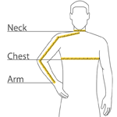

CHEST
With arms down at sides, measure around the upper body, under arms and over the fullest part of the chest.

NECK
Measure around the base of the neck, inserting a finger or two between the tape and neck for comfort.

ARM
Place hand on hip. Start at the center of the back of the neck and measure across the shoulder, to the elbow, and then down to the wrist.

SIZE CHART
 | XS | S | M | L | XL | 2XL | 3XL | 4XL | 5XL | 6XL
Chest | 32-34 | 35-37 | 38-40 | 41-43 | 44-46 | 47-49 | 50-53 | 54-57 | 58-60 | 61-63
Neck | 16 1/2 | 16 1/2 | 17 | 17 1/2 | 18 1/2 | 19 1/4 | 20 | 20 3/4 | 21 1/2 | 22 1/4
Arm | 30 1/2 | 32 | 34 | 35 | 36 1/2 | 37 1/2 | 38 1/2 | 39 1/2 | 40 1/2 | 41 1/2
Pocket Height | 5 1/4 | 5 1/4 | 5 1/2 | 5 1/2 | 5 1/2 | 5 1/2 | 5 1/2 | 5 3/4 | 5 3/4 | 5 3/4
Pocket Width | 4 3/4 | 4 3/4 | 5 | 5 | 5 | 5 | 5 | 5 1/4 | 5 1/4 | 5 1/4

#S508

HOW TO MEASURE
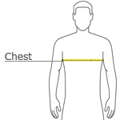

CHEST
With arms down at sides, measure around the upper body, under arms and over the fullest part of the chest.

SIZE CHART
 | XS | S | M | L | XL | 2XL | 3XL | 4XL | 5XL | 6XL
Chest | 32-34 | 35-37 | 38-40 | 41-43 | 44-46 | 47-49 | 50-53 | 54-57 | 58-60 | 61-63
Neck | 16 1/2 | 16 1/2 | 17 | 17 1/2 | 18 1/2 | 19 1/4 | 20 | 20 3/4 | 21 1/2 | 22 1/4

